

Product datasheet

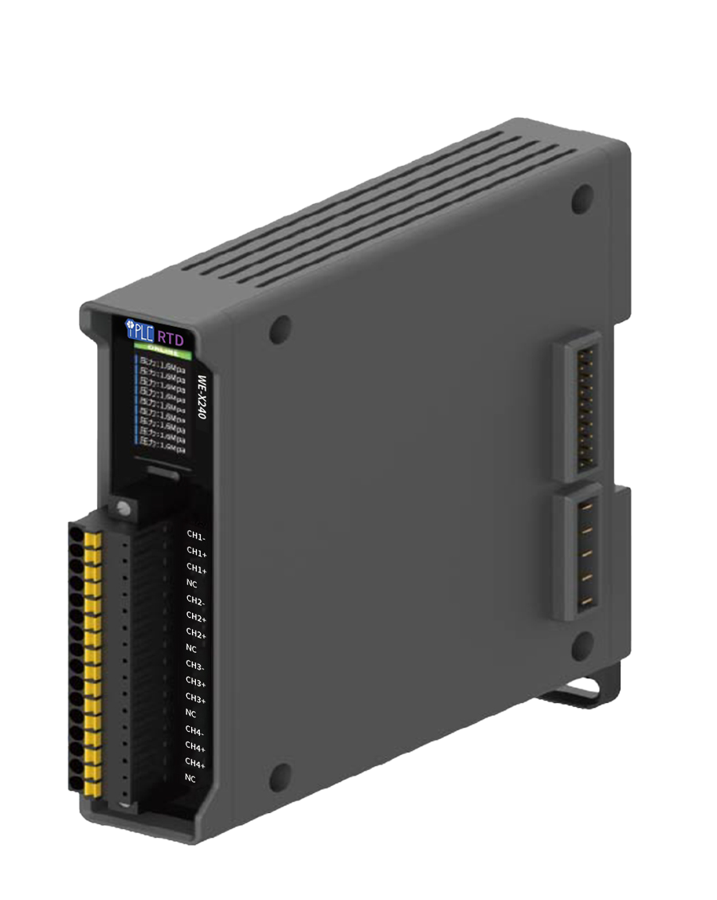(Change image)

WE-X240

Product Introduction

WE-X240 is an IO temperature acquisition module, which adopts extended structure design, flexible matching, small product size, guide rail installation, and space saving. Abundant indicator lights make it possible to judge the status of the device at a glance. With just one touch, the cascade of IO modules can be realized, which is simple to operate and easy to use.
At the same time, it can be combined with Shidian's T280, which perfectly interprets the flexible application mode of building block network IO.

Typical Applications

WE-X240 four-channel temperature acquisition module is a temperature measurement module developed by our company for various applications such as machinery, petrochemical, construction, and electric power. This module can be applied to SMT, pharmaceutical factories, electronic equipment factories, telecommunication rooms, cold storage, warehouses, air conditioning control systems and other occasions that need to detect temperature.

Features:

- Small size;
- Modular design, flexible expansion;
- High accuracy, can reach 0.5%;
- Rail installation method;
- Easy to integrate into a wide range of automation systems;
- It is easy to maintain and reduces the cost of ownership.

Specifications
Functional categories | Description of the function | remark
UI | 1* Key input | Page turn button, single function
UI | 2* LED indicator | Status indicator
UI | screen | 0.96 inches  80*160 dot matrix color LCD  Displays device information and status
Power supply | Power supply mode | Gateway-powered power
environment | Working environment | Operating temperature: -20~70°C  Working relative humidity: 5% ~ 95%, non-condensing
environment | Storage environment | Storage temperature: -30~80°C  Storage relative humidity: 5% ~ 95%, non-condensing
Degree of protection | Waterproof and dustproof | IP20
Degree of protection | ESD | 4KV contact, 8KV non-contact
Physical properties | Exterior dimensions | 25 (width) * 110 (height) * 117 (depth) mm
Physical properties | Housing material | ABS/PC
Physical properties | Installation: | Rail mounting
Physical properties | Wiring | 2-wire, 3-wire
I/O interface | Number of channels | 4
I/O interface | resolution | 0.1℃
I/O interface | precision | ±0.5% FSR @ 25°C
I/O interface | Temperature measurement range | -200~850℃

Wiring diagram

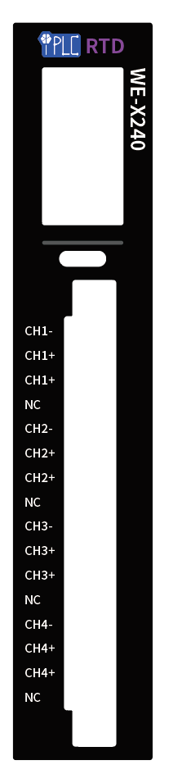
- Three-wire system:
  - Line A to CH-
  - The B line is not distinguished, and it can be connected to two CH+
- Two-wire system
  - Line A to CH-
  - The B line is connected to CH+, and the two CH+ need to be shorted externally
- When you change the RTD type, you need to set it on the web side
- If the type of setting on the web side is different from the type of external connection, it will lead to inaccurate temperature measurement and even damage to the device

